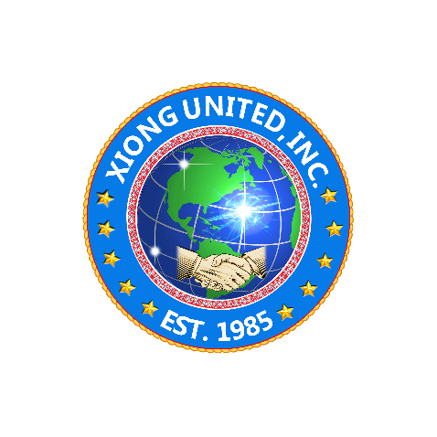 | Xiong United, Inc.  1013 W. Bellevue Rd.  Merced, CA 95348  Phone: (209) 631-3368  Email: admin@xiongunited.org Website: https://xiongunited.org

July 18, 2022

RE: Board of Director Representatives For Minnesota

Dear Neng Vang Xiong:

As stated in the Bylaws of Xiong United (XU), the state of Minnesota is entitled to have two people sit on the Board of Directors. Based on the meeting at your home on 6/5/22, we all agreed that you would inform XU regarding which two people would be representing Minnesota on the Board of Directors.

Currently, however, XU still has not heard from you. It is crucial that Minnesota has representation on the Board of Directors. If these two individuals have been selected, please submit their names and contact information to XU. If they have not been selected, please expedite the selection of the Minnesota representatives as soon as possible.

If you have any questions or if there is anything I could do to support you, don't hesitate to contact me at (209) 631-3368. Thank you, and I look forward to hearing from you soon.

Sincerely,
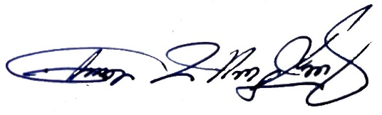
Chue Wang Xiong
President

